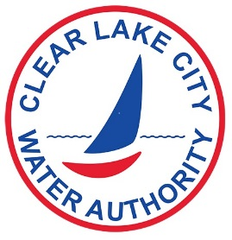
CLEAR LAKE CITY WATER AUTHORITY
900 Bay Area Blvd, Houston, Texas 77058
Phone: 281-488-1164 Fax: 281-488-6644
www.clcwa.org

REQUEST FOR DISCLOSURE OF PUBLIC RECORDS

Pursuant to the Public Information Act, Texas Government Code, Section 552, I hereby request the following information currently existing in the records of the Clear Lake City Water Authority:

List requested information as specifically as possible. A separate sheet may be attached if more space is needed.

If the requested documents (at $0.10 per page) total less than $1.00, there will be no charge for the copies. If the requested documents total $1.00 or more, you must pay for the documents in our office, check or cash only. If the request requires the information to be loaded onto a CD or flash drive, an additional charge will apply.

In making this request I understand that the Clear Lake City Water Authority is under no obligation to create a document to satisfy my request or to comply with a standing request for information will be released only in accordance with the Public Information Act, which may require a determination as to confidentially by the Texas Attorney General prior to release. I further understand that the Clear Lake City Water Authority has 10 business days in which to request such a determination.

______________________ __________________________________________________
Date Requester’s Signature

NAME: ____________________________________ PHONE:_________________________________

ADDRESS: _______________________________________________________________________________

EMAIL: __________________________________________________________________________________

